Integration Guide for Merchants
Channel Name
Contact details of the channel
incl. address

Version: Version number of the documentation
Date: Creation date of this version

Any legal notices, such as.
All rights reserved. This document contains proprietary information of <channel name> and may not be disclosed or used except in accordance with applicable agreements. This material is protected by copyright laws. This material may not be reproduced, distributed, or modified except in accordance with applicable agreements, contracts, or licenses without the written consent of the owner of this material.
Content
2 Data Structure 3
2.1 Product Data Structure 3
3 Structure of the Product Master Data 3
3.1 Product Group ID 4
3.2 Product Group Name 4
3.3 Brand 4
3.4 Category 4
3.5 Article ID 4
3.6 Article Name 5
3.7 Variant ID 5
3.8 Base Price 5
4 Qualitative Requirements 5
4.1 Data Quality 5
4.2 Article Name 6
4.3 Long Description 6
4.3.1 Obligatory Data 6
4.4 Product Images 6

1 General Information
Briefly introduce yourself to the merchant here.

2 Data Structure
General introductory sentence, such as
The product data exchange between you and us takes place via an XML file, which is provided via Tradebyte. The standards we provide are shown below.

2.1 Product Data Structure
Explanation of the product data structure of the marketplace, possibly with graphics, such as
- what is a product group?
- what is a product?
- what is a variant?
Beispielgrafik:
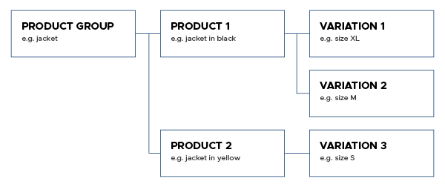

3 Structure of the Product Master Data
Brief explanation of the general meaning of the keywords used for definition, such as
- Level: Structure level in which the field is associated (e.g. product group, product, variant)
- - Mandatory/Optional: Specifying the field is mandatory or optional.
- Etc.
Below you will find examples of the product data structure used in the template. The design as well as the content of the data must be adapted to your circumstances.

3.1 Product Group ID
Level | Product group
Mandatory/Optional | Mandatory
Example | 1234567-001
Comment | The product group ID must be unique and corresponds to your identification number for the entire product group

3.2 Product Group Name
Level | Product group
Mandatory/Optional | Mandatory
Example | Jacket in black
Comment | Name for the entire product group

3.3 Brand
Level | Product group
Mandatory/Optional | Mandatory
Example | Test brand
Comment

3.4 Category
Level | Product group
Mandatory/Optional | Mandatory
Example | Cord jackets
Comment | The product must be assigned to a category.

3.5 Article ID
Level | Product
Mandatory/Optional | Mandatory
Example | 222999
Comment | This is your internal article number. This must be unique.

3.6 Article Name
Level | Product
Mandatory/Optional | Mandatory
Example | Jacket in black
Comment

3.7 Variant ID
Level | Variant
Mandatory/Optional | Mandatory
Example | var-xxx-1123
Comment | The variant article number must be unique and can correspond to the EAN

3.8 Base Price
Level | Variant
Mandatory/Optional | Optional
Value list  Measure unit | ml, l, mm, cm, m
Value list  Basic quantity | 1, 10, 100
Example | 2,45 €/m
Comment | The specification of the basic price is composed of the unit of measure and the basic quantity.

4 Qualitative Requirements
General introductory text to the bullet point, such as that the name and description of the product are crucial for purchase decisions, as are good product images.
Below are a few examples of subtopics.

4.1 Data Quality
What are the expectations regarding the delivered data?
For example: You should provide the category-specific properties of a product in the product information. For instance, the dimensions of a bed. This avoids returns due to insufficient information.
Make sure that your product data is free of errors. You are responsible for this.

4.2 Article Name
What are the requirements for the article name and what should be omitted?
Examples:
- Correct capitalization
- -Product-relevant specifications (e.g. color)
- No repetitions or long lists

4.3 Long Description
What are the requirements for the long description and what should be omitted?
Example:
- Highlight the benefits of the product
- Use complete sentences
- Check spelling
- No external links
- No information such as price or delivery time

4.3.1 Obligatory Data
For example, point out legal requirements, such as textile labeling regulations, real fur use or shoe labeling.

4.4 Product Images
What are the requirements for product images and what is not allowed?
Example:
- Which formats are allowed (png, jpg)?
- What is the minimum size of an image?
- What is maximum number of images?
- -No watermarks, logos or similar.
- What are the content requirements (e.g. masking)?
- Etc.

